PLEASE DO NOT ASK FOR EDIT ACCESS TO THIS DOCUMENT.
TO SAVE AN EDITABLE COPY TO YOUR DRIVE OR DESKTOP, PLEASE GO TO “FILE” AND THEN “MAKE A COPY.” FROM THERE, IT ALL YOURS TO DO WITH WHAT YOU LIKE.
The PESO Model Communications Plan Template

Organization Name:

BRAND VALUES | 1.  2.  3.  4.  5. | THE NEXT THREE YEARS  Future date:  Revenue:  Profitability:  What does our organization look like?
PASSION AND NICHE | Purpose/cause/passion:  Our niche:
WHAT DOES SUCCESS  LOOK LIKE? | What does success look like 10 years from now?
BUILT TO SUCCEED | Target market:  Key differentiators: 1.  2.  3.  Proven process name:  Supporting steps:
The PESO Model Communications Plan Template

Organization Name:

OUR 2019 BENCHMARKS | OUR MISSION | PRIORITIES | CHALLENGES
Domain authority:  SERPs on priority keywords:  1.  2.  3.  4.  5.  6.  7.  8.  9.  10.  Website visitors in 2019:  Email addresses in 2019:  Qualified leads in 2019:  Conversion % in 2019: |  | 1.  2.  3.  4.  5.  6.  7.  8.  9.  10. | 1.  2.  3.  4.  5.  6.  7.  8.  9.  10.

The PESO Model Communications Plan Template

Organization Name:

BRAND VOICE | BRAND QUALIFIERS | BRAND PERSONA | SMARTER GOALS
Our brand is (insert adjective) because we (insert reason). | - We always XXX  - We never XXX  - We believe XXX  - We support XXX | Reinforcer:  Supporter:  Challenger:  Why? | Goal #1:  Goal #2:  Goal #3:  Goal #4:  Goal #5:

The PESO Model Communications Plan Template

Organization Name:

PESO MODEL TACTICS | PRIORITY KEYWORDS | MEDIA LIST | SOCIAL MEDIA REFERRAL TRAFFIC
P:  E:  S:  O: | 1.  2.  3.  4.  5.  6.  7.  8.  9.  10. | 1.  2.  3.  4.  5.  6.  7.  8.  9.  10. | Twitter: %  Facebook: %  LinkedIn: %  Pinterest: %  Instagram: %  Others: %

The PESO Model Communications Plan Template

Organization Name:

FEBRUARY RESULTS | MAY RESULTS | AUGUST RESULTS | NOVEMBER RESULTS
Domain authority:  SERPs on priority keywords:  1.  2.  3.  4.  5.  6.  7.  8.  9.  10.  Website visitors:  Email addresses added:  Qualified leads added:  Conversion %: | Domain authority:  SERPs on priority keywords:  1.  2.  3.  4.  5.  6.  7.  8.  9.  10.  Website visitors:  Email addresses added:  Qualified leads added:  Conversion %: | Domain authority:  SERPs on priority keywords:  1.  2.  3.  4.  5.  6.  7.  8.  9.  10.  Website visitors:  Email addresses added:  Qualified leads added:  Conversion %: | Domain authority:  SERPs on priority keywords:  1.  2.  3.  4.  5.  6.  7.  8.  9.  10.  Website visitors:  Email addresses added:  Qualified leads added:  Conversion %:

Brand Voice Chart

Voice Characteristic | Description | Do | Don’t

SWOT Analysis

STRENGTHS | WEAKNESSES
OPPORTUNITIES | THREATS
Blank Content Map

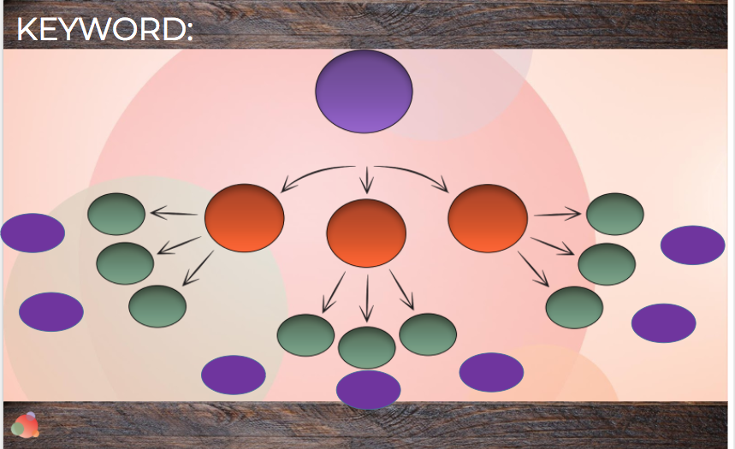

(This isn’t editable; it’s an image. You can find an editable copy here. Make sure you duplicate it and save to your Drive or desktop so you can edit it.)
Competition Spreadsheet

SITE | DOMAIN AUTHORITY | CAN COMPETE? | SEARCH VOLUME | COMPETITION
Keyword #1:

Weekly Social Media Activities

Weekly Social Media Activities
Sunday; 1/27/20 | Monday; 1/28/20 | Tuesday; 1/29/20 | Wednesday; 1/30/20 | Thursday; 1/31/20 | Friday; 2/1/20 | Saturday; 2/2/20
Twitter
LinkedIn
Blog
Facebook
Instagram

